BOOK CLUB PARTY GUIDE for ***MOZART’S BLOOD***

Along with the list of ten suggested discussion questions, here are a few ideas for turning your discussion of *Mozart’s Blood* into a party:

 If it’s appropriate, have an open bottle of Riesling in an ice bucket, in honor of Herr Mozart’s Viennese background. Teresa would love it if you offered a bottle of Italian red wine. Her favorite would be a Barolo, of course, but those can be expensive. A nice chianti is just fine, or a rich Brunello. For those who don’t drink wine, bottles of Pellegrino can be open and ready on the table.

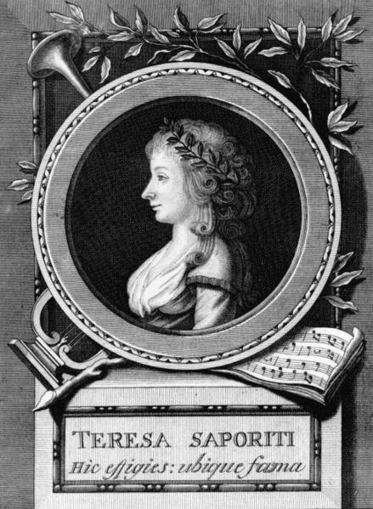 For a lunch or dinner party, a good pasta dish simply made with fresh ingredients will be perfect. Use fresh diced tomatoes, a third of a cup of good green olive oil, lots of chopped basil, a cup of pine nuts and a half cup of shaved parmesan cheese. Boil a pound of pasta and toss with all the other ingredients. It should serve six to eight.

With it serve a salad such as Ugo might have recognized. Layer peeled and sectioned grapefruit with avocado slices onto salad plates, and drizzle with garlic-infused olive oil. The grapefruit sections that come in glass jars are fine, but drain them well. Garnish with even more fresh basil leaves (you can never have too much).

A loaf of fresh Italian bread served with olive oil for dipping rounds out your table!

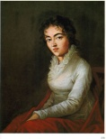 Dessert is simplest of all. If your club doesn’t serve a full meal, this will energize them for the discussion! Arrange an assortment of dark chocolate truffles on an elegant plate, and serve with a good Viennese coffee. Side dishes can be nuts and cheese and olives. Shop for Mediterranean-themed cocktail napkins!

 Most of the pictures you see here, such as this one of Teresa’s birthplace, are free for download from the internet. Download and print in a good size, and use them to decorate. You can paste them to cardboard or even put them in inexpensive picture frames.

 And now the best part: the music! Begin with a good recording of *Don Giovanni,* preferably featuring Renee Fleming. Any of the symphonies would be lovely, particularly the familiar ones such as Symphony #40 in G minor, or the Symphony #25. The score for the movie *Amadeus* would be perfect, as it offers tidbits of all the familiar passages.

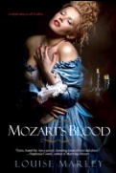 Halloween is the perfect time to read a book like *Mozart’s Blood*, and you could have your guests come in costume! It might be hard to achieve Octavia’s beautiful gown here, but you have so many periods to choose from—the 18th century, the late 19th century, the Roaring Twenties, even the clothes of World War II. Costumes are fun to research. Googling the period you want to use is easy.

If you do dress in period costumes, take good pictures! We would love to put them on the website. *Salute! E buon gusto!*